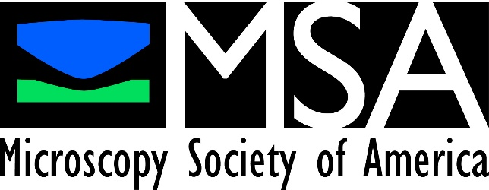

The Microscopy Society of America

Questions? Contact associationmanagement@microscopy.org

Submission Guidelines

MSA Strategic Initiatives Program

Summary

This document provides detailed guidelines to assist with the submission of proposals to the Microscopy Society of America’s Strategic Initiative Program, a program that provides funding to support bold and innovative initiatives that advance the mission, vision, and goals of MSA.

**Overview**

All of the following components must be included in the application. We reserve the right to reject incomplete proposals or those that do not follow the format guidelines below.

**Application Requirements**

The application should consist of the following:

* a cover page,
* a narrative no longer than three pages,
* a budget justification no longer than two pages,
* and a completed budget proposal spreadsheet.

The proposal document should be single spaced, with margins no less than 0.5 inches, typeface with average of 15 characters per inch (e.g., Times New Roman 12 point) or less, and no more than 64 lines per page. Detailed information on each element of the application is available in the next section.

**Detailed Description of Application Elements**

**Cover Page**

* Project title and information about the project leader(s).
* The full name and contact information for the project leader(s) . Usually, the project will be headed by one key person, but co-leaders are allowed if appropriate and justified. Information about other personnel participating in the project will be requested in a separate part of the application form.
* The full names, affiliations, and contact information for other key personnel.
* A project description in the form of an executive summary (6 sentences or less).

**Narrative**

The project narrative must be no longer than 3 pages in length with the specific proposal content sections listed below, labeled with appropriate headers.

**Proposal Content Guidelines**

Strategic Area Being Addressed and Justification

Provide a short background of why the initiative is needed and how the proposed initiative addresses one or more of the areas of interest identified by MSA Council.

Details of the Proposal

Provide details of the plan, the intermediate and final goals (if applicable), how outcomes will be measured, and how success will be assessed. **This is an absolute requirement and a key component of proposal review.**

Discuss what will be accomplished in the short and long term as a result of implementation of the proposed initiative.

Innovation and Impact

Specifically address the innovative aspects of the proposal.

Specifically address the impact of and how the success of the proposal will further the strategic goals of MSA.

Plan for Long-Term Support

If the proposal involves a program or activity that is expected to continue after the end of the Strategic Initiative funding, address the plans for continued financial support. Ongoing financial support from the MSA is an option, but other forms of support are highly encouraged.

If the proposed program or activity does not require ongoing support, include a statement to that effect in the proposal. For example, “This activity does not require financial support after the end of the Strategic Initiative funding.”

**Budget Justification**

A proposed budget, up to 2 pages in length, is required and should provide reasonable detail about how funds will be used. It should indicate the total amount of money being requested and a breakdown, line by line, of individual expense categories and dollar amounts required for each line item. Line items can be broad in nature but should be explained and justified in the budget justification. MSA is a non-profit scientific society driven by volunteers, and salary support in budgets meant to replace volunteer effort is discouraged.

**Budget Proposal Spreadsheet**

Please use the Budget Proposal Template (Excel) found at this link: <https://microscopy.org/files/galleries/SI-Budget-Proposal-Submission-Form-TEMPLATE.xlsx>

**Other budget proposal formats will NOT be accepted.**

The review committee will determine whether the budget is reasonable and may suggest modifications. This information will be passed on to the full MSA Council during final project assessment. Budget issues are considered separately and do not affect the merit score of the proposal.